**Harmony**

**Primary**

**School**



**‘Excellence in Education**

**rooted in an Islamic Ethos’**

Prospectus

2020 / 2021



## Our Ethos

‘Based upon the guiding principles of Islam we seek to engender the precious tenets of our Faith Ethos into the life and character of our School ’

## Our Harmony Mission

‘Harmony Primary School aims to bring out the best in each individual, striving for excellence on a daily basis; at HPS we lay down strong academic roots as our children are enriched by a broad, balanced curriculum that nurtures their abilities. Our school harmoniously bring together our children, parents & educators to cultivate an inspiring learning experience

rooted in an Islamic ethos.’

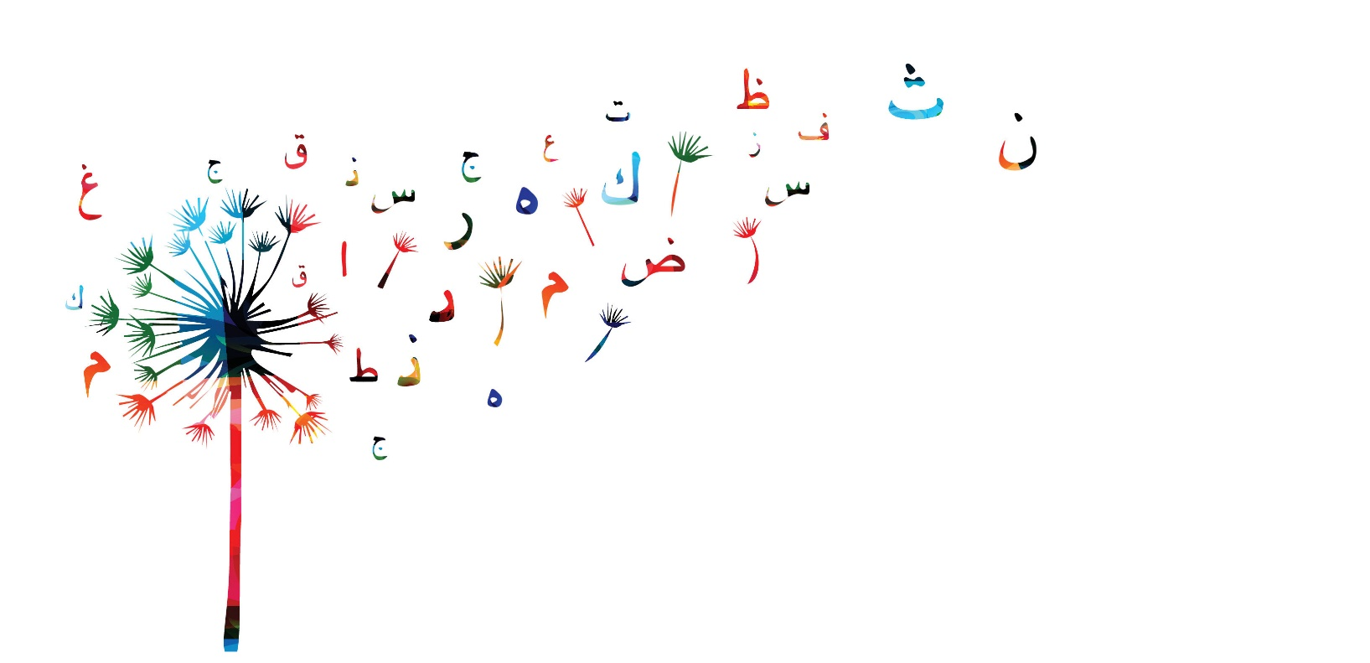

.

## Our Harmony Tree

Our vision and educational goals are represented by ‘The Harmony Tree’; the tree has at its core roots, trunk and branches.

Harmony’s roots represent the guiding principles of our ethos. The trunk signifies the body of our holistic curriculum and the branches are the means of delivering it. Our curriculum will be delivered through the four branches: Core, Broad, Extended and Enrichment.

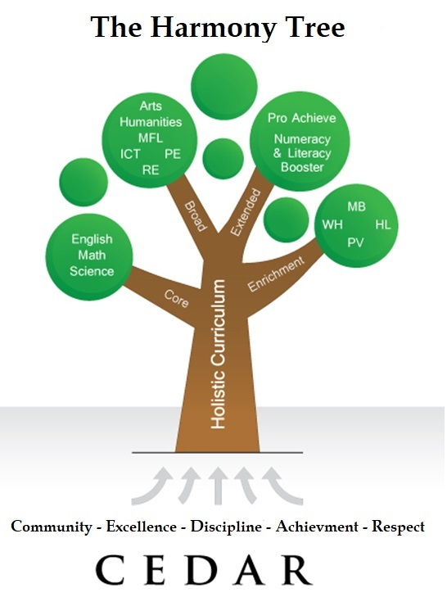

## **Our Harmony Roots**

Harmony Primary School’s ‘roots’ represent the underlying values of our Islamic Ethos enabling each student to unlock their full potential.

### Community

### Our Community Root fosters strong links between Harmony Primary School and wider society and encourages our students to appreciate differences in age, ethnicity and social background. Through this key value our students will be engaged with a range of opportunities which will strengthen their understanding of the world around them and prepare them to be conscientious members of society.

### Excellence

Our Excellence Root will be the driver students, teachers and parents aspire to for the highest levels of excellence in all their endeavours, whether academic, skills based and in any other respect.

### Discipline

Our Discipline Root is drawn directly from our Islamic ethos; students are taught to appreciate the benefits of leading a disciplined lifestyle through the character building nature of our Islamic ethos.

### Achievement

Our Achievement Root reflects our commitment to provide an outstanding academic curriculum that is broad and balanced with equal opportunities for every student. Our students’ attainment will be set against nationally recognised benchmarks and teachers will closely monitor the attainment and progress of each student tailoring bespoke educational plans to meet every child’s individual needs.

### Respect

Our Respect Root cultivates respectful attitudes between students, teachers, parents, carers and the wider community. We are dedicated to promoting a safe environment where students can thrive as individuals while understanding their responsibilities to the wider school community and our attention to encouraging social consciousness will link to the commitments we make in our extended curriculum.

## Our Commitment to Excellence in

## Education

**Based on the national curriculum and accented with a variety of distinctive features our holistic curriculum will benefit from the latest state of the art technology. Our small class sizes allow our teachers to tailor their delivery to the needs of each student ensuring each child has the support they need to flourish.**



Our Branches

#### At Harmony Primary School our children benefit from a rich and varied curriculum that nurtures their core academic skills which is delivered through four branches: Core; Broad; Extended and; Enrichment.

### Core Branch

The heart of our curriculum - our Core branch - will drive attainment in Numeracy and Literacy.

### Broad Branch

Our Broad branch widens our children’s horizons through exploring an array of subjects including humanities, languages and arts subjects as outlined in the National Curriculum Foundation subjects.

### Extended Branch

Our school will seek to further the development of every student through the delivery of carefully structured supplementary programmes which will support and challenge students according to their individual needs.

### Enrichment Branch

Our enrichment branch furthers the delivery of our curriculum and ethos bringing a wealth or experiences and interactions to nourish our students; through this branch we will sculpt the Islamic character of our children developing their understanding of the world around them whilst maintaining the strong roots of our traditions and values.

About us

Harmony Primary School is an association of Educationists and Professionals working together to return the benefits of our experience in our community here in the UK, the very communities in which we were raised… With a desire to empower the next generation and a passion for core Islamic Values we set about establishing an inspiring new school preparing our children for life in Modern Britain.

FIND US:

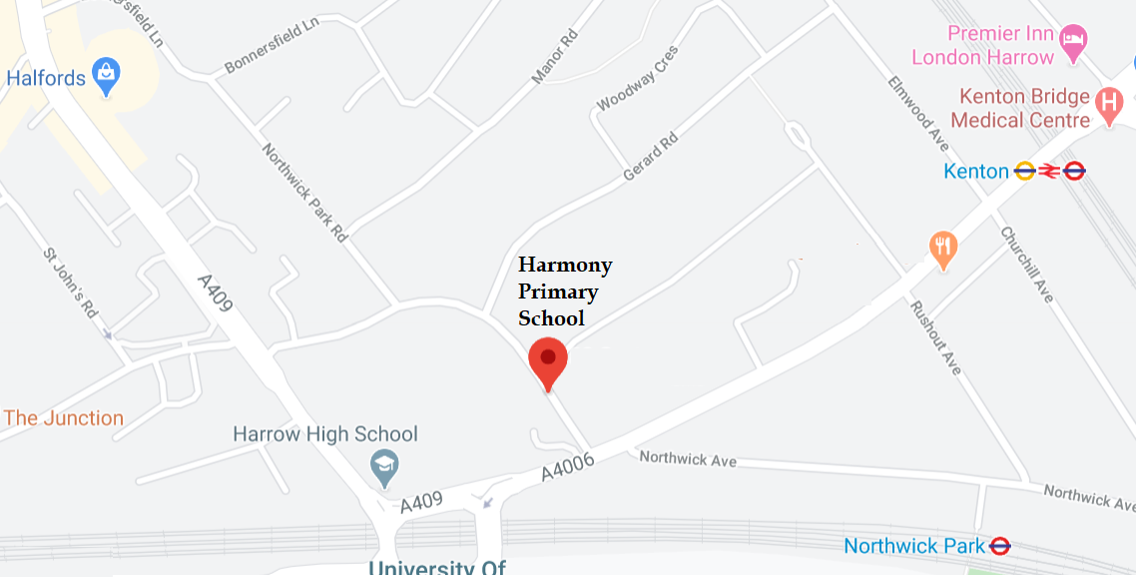

**Admissions Office** Harmony Primary School

80 Gayton Road, Harrow, HA1 2LS

**Tel:** 0208 427 4688

**Email:** [admin@harmonyprimaryschool.co.uk](mailto:admin@harmonyprimaryschool.co.uk)